# a)

## Code

close

clc

clear

t=[0:pi/10:pi];

x=sin(t);

y=cos(2*t);

plot(x,y,'-O','LineWidth',2,'color','r','MarkerSize',6,'MarkerEdgeColor','b','MarkerFaceColor','b')

xlabel('Sin(x)');

ylabel('Cos(2x)');

## Output

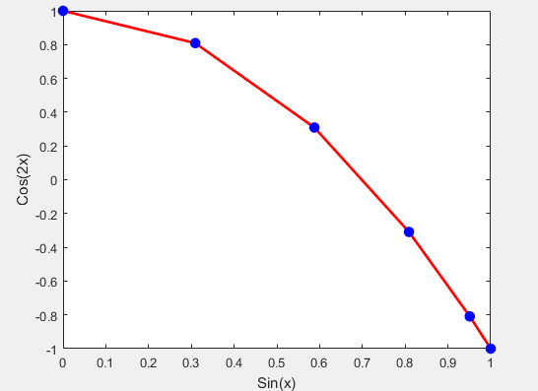

# b)

click on edit menu and select figure properties

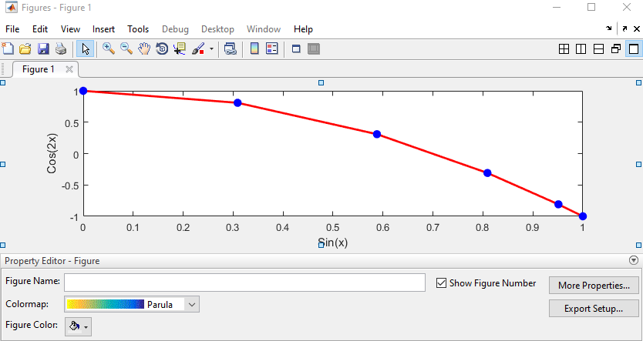

Click on more properties



Click on marker from list and select square from top down menu. select black color from MarkerEdgeColor and MarkerFaceColor.

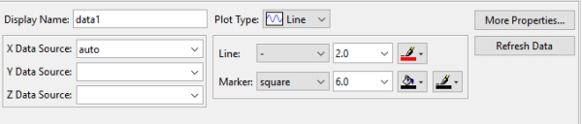

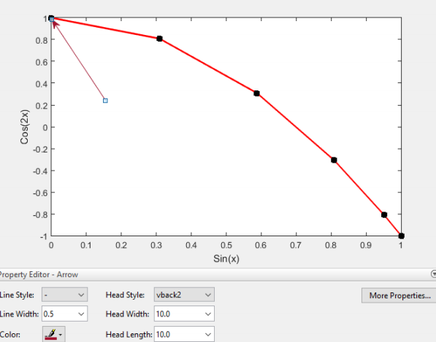

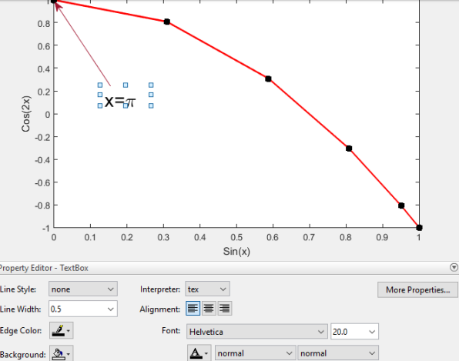

# c)

## Code

clc

close

clear

st='f(x)=sin($\theta$)cos(2$\phi$)';

text('string',st,'interpreter','latex','fontsize',20,'pos',[0.25,0.5])

## Output

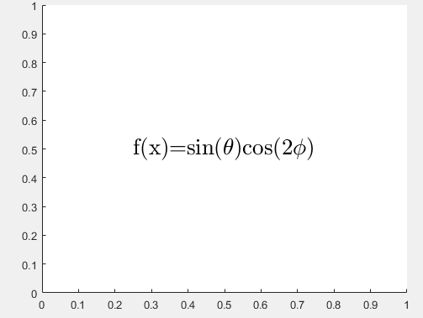

# d)

## code

clc

clear

close

x=linspace(1,10,10);

sum_sqrx=zeros(1,length(x));

for i=1:length(x)

sum_sqrx(i)=sum_sqrx(i)+x(i)^2;

end

plot(sum_sqrx,x)

xlabel('square of x')

ylabel('x')

grid on

## output

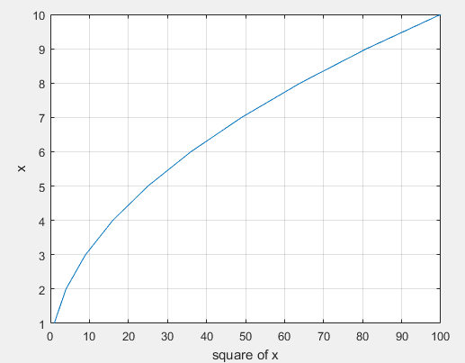

# E

## Code

text(0.25,0.5,'\tau\it_{m}');

## Output

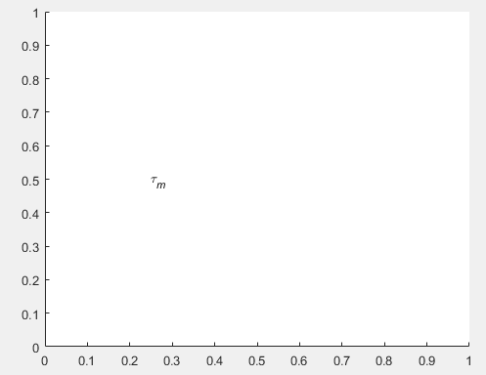

# F

## Code

text(0.25,0.5,'\bf\itx_{1}^{2}+x_{2}^{2} \rm(units:\bfm^{2}\rm)')

## Output

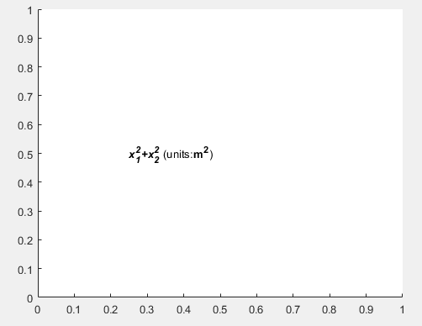

# G

## Code

clc

clear

close

theta=0:0.01*pi:2*pi;

r=10*cos(3*theta);

polar(theta,r)

## Output

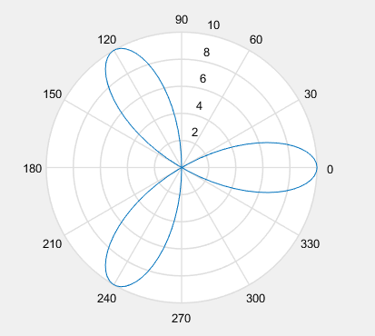

# H

## Code

clc

clear

close

x=0.01:0.1:100;

y=1./(2*x.^2);

plot(x,linspace(min(y),max(y),length(x)))

title('linear plot')

xlabel('x')

ylabel('y')

grid on

figure(2)

plot(x,logspace(min(y),max(y),length(x)))

grid on

title('loglog plot')

xlabel('x')

ylabel('y')

## Output

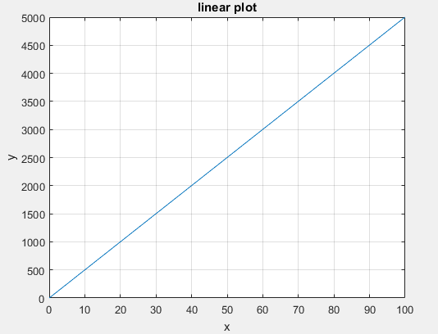

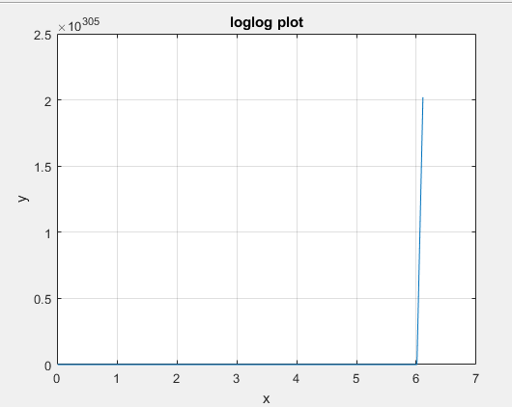

The shape of loglog plot down to zero and suddenly move to upper and change from 0 to 2,